Supply Base Report for Stolbtsovski leshoz

www.sbp-cert.org

Completed in accordance with the Supply Base Report Template Version 1.3

For further information on the SBP Framework and to view the full set of documentation see www.sbp-cert.org

Document history
Version 1.0: published 26 March 2015
Version 1.1 published 22 February 2016
Version 1.2 published 23 June 2016
Version 1.3 published 14 January 2019

© Copyright The Sustainable Biomass Program Limited 2019

Contents
1 Overview 1
2 Description of the Supply Base 2
2.1 General description 2
2.2 Actions taken to promote certification amongst feedstock supplier 5
2.3 Final harvest sampling programme 5
2.4 Flow diagram of feedstock inputs showing feedstock type [optional] 5
2.5 Quantification of the Supply Base 6
3 Requirement for a Supply Base Evaluation 7
4 Supply Base Evaluation 8
4.1 Scope 8
4.2 Justification 8
4.3 Results of Risk Assessment 8
4.4 Results of Supplier Verification Programme 8
4.5 Conclusion 8
5 Supply Base Evaluation Process 9
6 Stakeholder Consultation 10
6.1 Response to stakeholder comments 10
7 Overview of Initial Assessment of Risk 11
8 Supplier Verification Programme 11
8.1 Description of the Supplier Verification Programme 12
8.2 Site visits 12
8.3 Conclusions from the Supplier Verification Programme 12
9 Mitigation Measures 12
9.1 Mitigation measures 13
9.2 Monitoring and outcomes 13
10 Detailed Findings for Indicators 13
11 Review of Report 15
11.1 Peer review 15
11.2 Public or additional reviews 15
12 Approval of Report 15
13 Updates 17
13.1 Significant changes in the Supply Base 17
13.2 Effectiveness of previous mitigation measures 17
13.3 New risk ratings and mitigation measures 17
13.4 Actual figures for feedstock over the previous 12 months 17
13.5 Projected figures for feedstock over the next 12 months 17

Overview
Producer name: Stolbtsovski leshoz
Producer location: 17 Sentiabria Street, 15, Stolbtsy, Minsk Region, Republic of Belarus, 222666
Geographic position: 53°28’25.3”N
26°45’20.3”E
Primary contact: SpilevskiGennadiiStanislavovich17 Sentiabria Street, 15, Stolbtsy, Minsk Region,
Republic of Belarus, 222666
Tel.+375-1717-78837
email: stolbzyles@tut.by
Company website: http://stolbzyles.by
Date report finalised: 21/06/2019
Close of last CB audit: 24/06/2019
Name of CB: NEPcon
Translations from English: Yes
SBP Standard(s) used: SBPStandard 2: Verificationof SBP-compliant Feedstock
(Version 1.0, March 2015)
SBPStandard 4: Chain of Custody (Version 1.0, March 2015)
SBPStandard 5: Collection and Communication of Data
(Version 1.0, march 2015)
Weblink to Standard(s) used: www.spbo-cert.org/documents
SBP Endorsed Regional Risk Assessment: Not applicable
Weblink to SBE on Company website: Not applicable

Indicate how the current evaluation fits within the cycle of Supply Base Evaluations
Main (Initial)  Evaluation | First  Surveillance | Second Surveillance | Third  Surveillance | Fourth  Surveillance
☐ | ☐ | ☐ |  | ☐

Description of the Supply Base

General description
2.1.1 Belarus, forest resources
Forest resources of Belarus as an aggregate of all natural and homogeneous national forests include woodlands and other lands allotted for forestry. Total area of forest resources is 9.5mln ha, including 8.2mln ha of forested area (with no glades, hewn or burnt-out places). The percentage of forest lands in Belarus is about 40% that is optimal for our country in general. Seeevolutioninthefigurebelow.

Evolution of the percentage of forest lands in Belarus
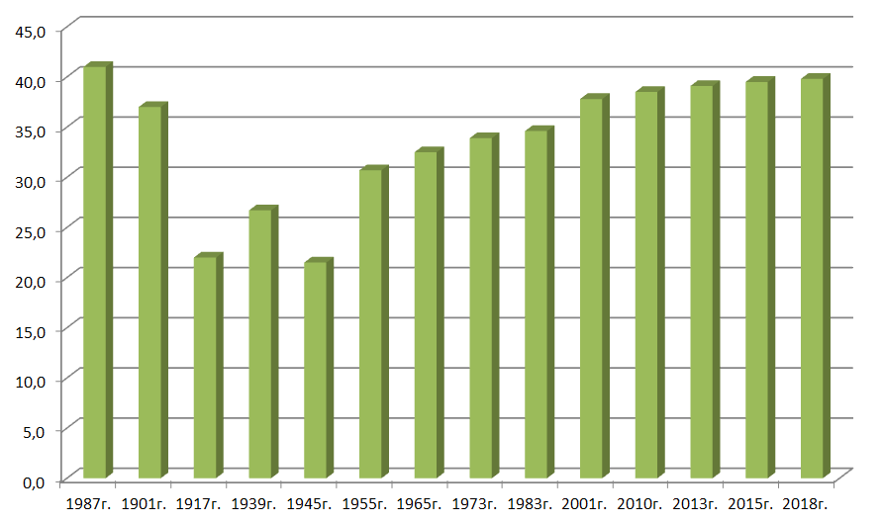
Forest resources of Belarus are quite well studied. Experts estimate timber volume in 2018 equal to 1796.0mln m³ including approximately 296,0mln m³ of commercial timber (mature and overmature wood). Total annual forest gain is about 32.1 mln m³. Average age of Belarusian forests is 56 years. Forested area is distributed by age as follows: 18.7% of young growth, 46.0% of middleaged stand, 22.8% of ripening stand, 12.5% of mature and overmature wood (see the figure below).
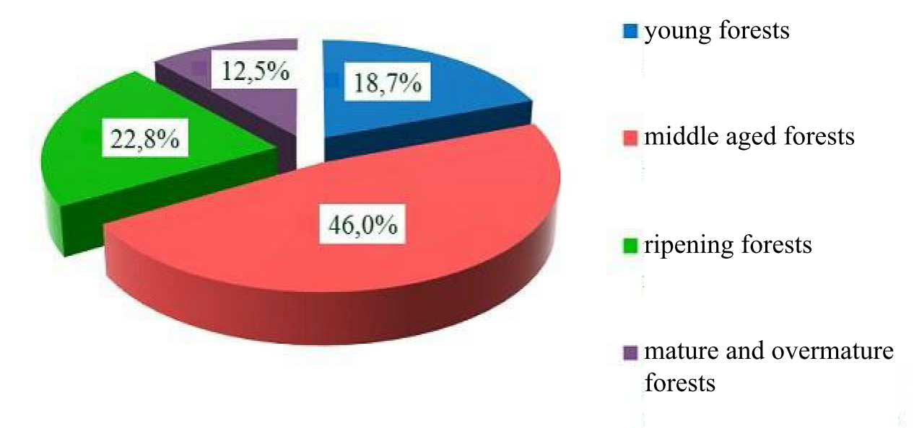
Forest exploitation in Belarus implies continuity and inexhaustibility. Annualaverageloggingis 10.0 to 11.2 mlnm³including 4.3 to 4.5 mln m³ (40%) ofmajorharvest(in mature stands), 5.4 mln m³ (48%) of maintenance and sanitary cuts (young, middle aged and ripening forests), 1.0 to 2.3 mln m³ (12%) of other felling types. Forest exploitation is expected to intensify in the followingpotentially to over 16 mln m³ in 2011-2015 and to over 19 mln m³ in 2016-2020. However, it is not going to be unsafe for forests in view of the current annual forest gain in Belarus about 25 mln m³. Moreover, the annual forest gain is getting bigger and bigger as the percentage of forest lands grows and age structure of forests gets more uniform. Forest exploitation practice is primarily dependent on annual allowable cut. Only 70% to 80% of the quota has been used in recent years. Underuse is mainly related to soft-wooded broadleaved species, small merchantable wood and hard-to-reach areas where felling is not reasonable economically. Lack of capital investments limits wood usage in energetics. Average annual forest exploitation rates have been equal to not more than 1.5 to 1.7 m³ per 1 ha of forested area in recent years – thatis 2.4 times less than the annual wood gain equal to 3.6 m³/ha.
Forest and wood working in dustries
Belarusian forest industry consists of forestry (13.5% of total output), woodworking (69.5% of total output) and pulp-and-paper (16.4% of total output) sectors. Sawmilling has been a major activity historically, and today about 1500 enterprises are certified to produce saw timber. Most of them combine the latter with mechanical woodworking (windows and doors, wood-frame houses) or wood harvesting. State forestry institutions possess their own woodworking facilities dedicated to machining own round timber.
Currently 8,39mln ha of forests in Republic of Belarus are FSC-certified, and 144 CoC certificates are received.

2.1.2 Stolbtsovski leshoz
The supply base of the organization is the total territory of Stolbtsovski leshoz.
Forests are the dominant vegetation type on the territory of the GLHU «Stolbtsovskileshoz». The structure of the FME includes Okinchitskoe, Opechkovskoe, Prudskoe, Nalibokskoe, Kulskoe, Kletischenskoe, Rubezhevichskoe, Starinskoe and Hotovskoe forestry areas and the logging unit. The FME is located in the western part of the Minsk region, within the Stolbtsy administrative district. The total area of the FME is 90 029 hectares, including 83 005 hectares covered by forest. Compare to last reporting period the supply base area was increased because of acceptance of former agriculture lands into forest fund.
Distribution of forests by groups - Group 1 makes 73.6% and Group 2 makes 26.4%. Distribution by age groups - the young forests make 19.6%, middle forests make 55.4%, maturing forests make 20.2% and over-ripe forests make 4.8%. The distribution by dominant species – coniferous forests make 75.6%, hardwood forests make 0.5% and deciduous forests make 23.9%. Average wood volume is 220 m3 per hectare. Average age of trees is 54 years. The limit of cutting of mature trees is 67,100 cubic meters, including 34,100 cubic meters for coniferous. They are pine – 22,700 m3, spruce – 6,400 m3, aspen – 3,000 m3, birch – 11,900 m3, black alder – 18,100 m3. All clear cuts are planted by trees in the spring or forest plots are left for natural regeneration. All artificial forests are annually under care.
The main objective of forest management in the GLHU «Stolbtsovskileshoz» is to provide the continuous, stable, sustainable, cost-effective, multi-purpose, environmentally responsible and socially oriented forest management that to meet the needs of society in raw materials and to preserve and enhance the ecological functions of forests and to conserve biodiversity in forest ecosystems.
The feedstock for pellet production is classified as SBP-compliant secondary feedstock (FSC 100% SBP compliant secondary feedstock/sawdust, residues) and SBP compliant primary feedstock (for drier only).The main species are Scots pine (Pinussilvestris) -86%, Spruce (Piceaabies) -14%.
Table 1. Distribution of feedstock by types of SBP product groups for the second reporting period.
SBP product group | % inthetotalsupply | Number of suppliers | Treespeciescomposition
Controlled feedstock | 0% | 0 | -
SBP- compliant primary feedstock | 5,6% | Own wood harvesting | 10% Norway Spruce,  90% Scots Pine
SBP- compliant secondary feedstock | 94,4 % | Residues of own wood processing
SBP- compliant tretiary feedstock | 0% | 0 | -
SBP non-compliant feedstock | 0% | 0 | -

Actions taken to promote certification amongst feedstock supplier
Not applicable. Stolbtsovski leshoz uses only FSC-certified wood grown at company’s territories.

Final harvest sampling programme
Stolbtsovski leshoz produces fuel pellets of saw dust by own sawing and machining facilities, only. Primary feedstock from clear cuts of 81 year is used for heating purposes. However, these clear cuts are not conducted with the purpose of using this wood as a feedstock for biomass production.

Flow diagram of feedstock inputs showing feedstock type [optional]
Stolbtsovskileshozproduces fuel pellets ofsaw dust by own sawing and machining facilities, only, of the following species (according to process data byOkinchitsy production and logging camp):
- 90% of Scotch pine (Pinussylvestris)
- 10% of Norway spruce (Piceaabies)
Step | Productflowandcheckpoints
1 | Forestry activity at own territory 100% FSC-certified
2 | Timber sawing at own Okinchitsy production and logging camp
3 | Production of fuel pellets of saw dust at Okinchitsy production and logging camp
4 | Vehicles (electric train) for transportation to the Belarus-Latvia border

Quantification of the Supply Base

Supply Base
a. Total Supply BaseArea (ha): 90 029 ha
b. Tenure by type (ha): 90 029 ha Government of the Republic of Belarus
c. Forestby type (ha): 90 029 ha Temperate
d. Forest by management type (ha): 90 029 ha Managed natural
e. Certified forest by scheme (ha): 90 029 ha FSC

90 029 ha PEFC

Feedstock
f. Total volume of feedstock 7183,99m³ per year
g. Volume of primary feedstock Not applicable
h. List percentage of primary feedstock (g), by the following categories. Subdivide by SBP-approved Forest Management Schemes:
- Large forest holdings certified to an SBP-approved Forest Management Schemes – 100% FSC 100% (fuel wood, as fuel for heat generator)
- Large forest holdings not certified to an SBP-approved Forest Management Schemes – 0%
i. List all species in primary feedstock, including scientific name.
- Scotch pine (Pinussylvestris);
- Norway spruce (Piceaabies).
j. Volume of primary feedstock from primary forest. Notapplicable (0 m³).
k. List percentage of primary feedstock from primary forest (i), by the following categories. Subdivide by SBP-approved Forest Management Schemes.
- Primary feedstock from primary forest certified to an SBP-approved Forest Management Schemes
- Primary feedstock from primary forest not certified to an SBP-approved Forest Management Schemes
Not applicable (0 m³).
l. Volume of secondary feedstock: 7183,99 m³ - saw dust by own sawing and woodworking facilities (for production – 6295,99 m³ and for heating – 888,3m³).
m. Volume of tertiary feedstock: Not applicable (0 m³)

Requirement for a Supply Base Evaluation
SBE completed | SBE not completed
☐

SBP pellets are produced of FSC-certifiedwood, i.e. 100% of total pellet production is 100% FSC-certified. Supply BaseEvaluation is not required.

Supply Base Evaluation

Scope
Not applicable.

Justification
Not applicable.

Results of Risk Assessment
Not applicable.

Results of Supplier Verification Programme
Not applicable.

Conclusion
Not applicable.

Supply Base Evaluation Process
Not applicable.

Stakeholder Consultation
Not applicable.

Response to stakeholder comments
Not applicable.

Overview of Initial Assessment of Risk
Not applicable.

Supplier Verification Programme

Description of the Supplier Verification Programme
Not applicable.

Site visits
Not applicable.

Conclusions from the Supplier Verification Programme
Not applicable.

Mitigation Measures

Mitigation measures
Not applicable.

Monitoring and outcomes
Not applicable.

Detailed Findings for Indicators
Not applicable.

Review of Report

Peer review
Peer Review of Report on Supply base of State Forestry Institution “Stolbtsy Forestry Enterprise”
28.03.2016
Expert’s qualification: Sergei VladimirovichKovalevskii, a 1998 graduate of 1998 from Belarusian State Technological University, Forestry Faculty; a postgraduate from Forest Management department, and a PhD in Agriculture. MrKovalevskii is a highly experienced party to the National Forestry Scientific Programme projects related to forest conservation and environmentally friendly forestry.
Expert’s opinion: The Report on Supply base of State Forestry Institution “Stolbtsy Forestry Enterprise” (the Report) was reviewed. Company’s forest resources are located in western Minsk Region, Belarus. The enterprise uses coniferous timber harvested in its own forest resources as feedstock. Therefore the Report briefly describes forest resources of State Forestry Institution “Stolbtsy Forestry Enterprise” and condition thereof. The review revealed no gross violation or figure misinterpretation. The Report refers to official data sources in order to prove given information and conclusions. General description of Belarusian forest resources contains main properties like forest area, gross annual gain, total stand stock, harvesting intensity, range of species, etc. Wood supplies from proper forests, only, imply extremely low risk of purchasing wood from high nature value forests, radionuclide-contaminated wood, and other.FSC-certifiedwood from proper forests minimizes the risk to purchase wood from a doubtful source.
Reviewer
Forest Management Department Associate Professor
PhDinAgriculture (signed) S.V. Kovalevskii

Public or additional reviews
The Report in Russian is available for public awareness to whom it may concern on Stolbtsovski leshoz website http://stolbzyles.by/certification.
Anyone concerned may provide feedback to e-mail:stolbzyles@tut.by.

Approval of Report
Approval of Supply Base Report by senior management
Report Prepared by: | Lamaka Andrei Mechislavovich | Standardization and certification engineer | 21/06/2019
 | Name | Title | Date
The undersigned persons confirm that I/we are members of the organisation’s senior management and do hereby affirm that the contents of this evaluation report were duly acknowledged by senior management as being accurate prior to approval and finalisation of the report.
Report approved by: | Gennadii Stanislavovich Spilevski | Chief Engineer | 21/06/2019
 | Name | Title | Date
Report approved by: | Gennadii Vikentievich Kazhushko | Director | 21/06/2019
 | Name | Title | Date

Updates
Not applicable.

Significant changes in the Supply Base
Not applicable.

Effectiveness of previous mitigation measures
Not applicable.

New risk ratings and mitigation measures
Not applicable.

Actual figures for feedstock over the previous 12 months
6465.60 tons peryear

Projected figures for feedstock over the next 12 months
8100 tons of saw dust are expected to be produced, used and processed.

